Germany Summer Work
Mandatory Tasks

- Watch or listen to the BBC lecture below. (Accounts are free). Make a brief mind map or flowchart – how does the Brandenburg Gate help us understand the changes in Germany over time?
https://www.bbc.co.uk/sounds/play/b04dwckb

- Read this article OU Otto Steineke reading.pdf written in 1929. (You can also access it here by scrolling to the bottom of the page and clicking Source 1.)

Then look at the U-Bahn map of Germany in the 1920s below.
What impression does this give you of Germany in the inter-war period? Consider living conditions, economic conditions, information we’re given about the political situation, and family life.
Write around 200-300 words with your impressions of Germany in this period.
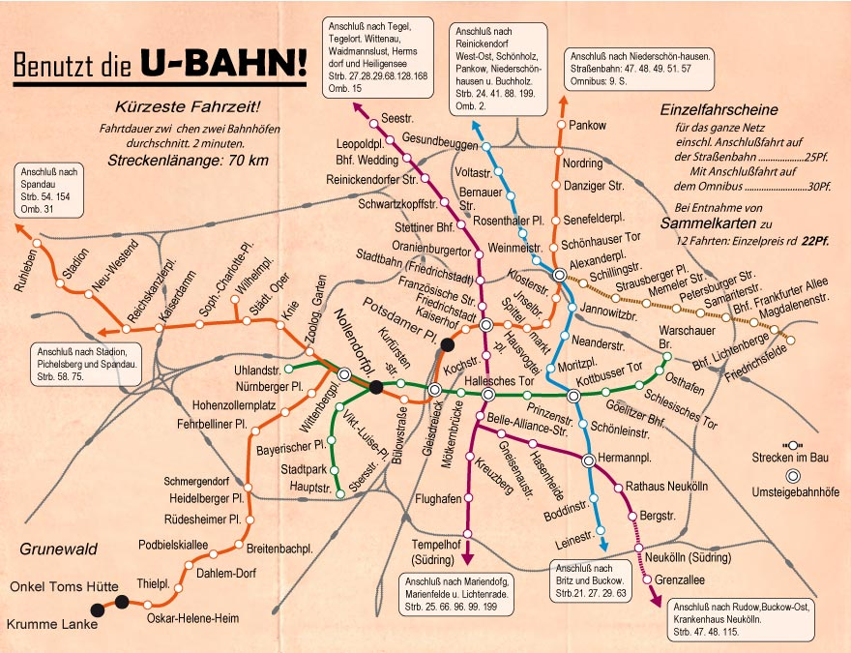

- Understanding and using historical vocabulary is key for success in your A-Levels. Research and write definitions for these key terms below, and if possible include which period/s of German history they are most relevant to in your course.
Term | Definition | Period/s of Germany it is most relevant to
Authoritarianism
Volksgemeinschaft
Gleichschaltung
Coalition government
Proportional representation
Constitution
Police state
Marxism-Leninism
Wirtschaftwunder
Freikorps
Article 48
SED
Chancellor
Gauleiters
Iron Curtain
Fuhrerprinzip
Working towards the Fuhrer
Nationalisation of industry
Autarky
Operation Rose (1961)
FDJ
Volkskammer

- Watch at least Episode 1 of this series on the Rise of the Nazis. https://www.bbc.co.uk/iplayer/episode/m00084tb/rise-of-the-nazis-series-1-1-politics?seriesId=m00084td-structural-1-m00084tc

(Note, if that episode link has expired from BBC iPlayer, you can watch the episode here instead)

Create a mind map with knowledge as you watch and bring it with you in the first lesson in September.

How did Adolf Hitler begin to rise to power in Germany through the 1920s? How did the political system enable him to do that, and what other factors contributed to his rise?

Unit A of your Germany paper will focus on this topic, so a good grounding in knowledge will help you considerably.

